1. Chcek if the Directory is Available or Not.

2) Create a bash script which will create multiple files.

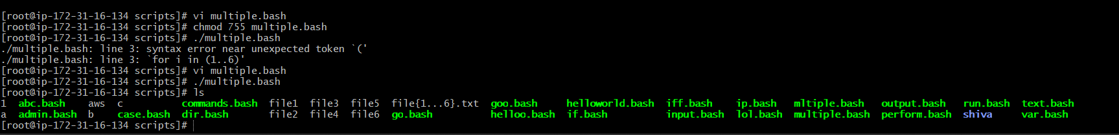

3) Create a bash script to take backup of a directory.

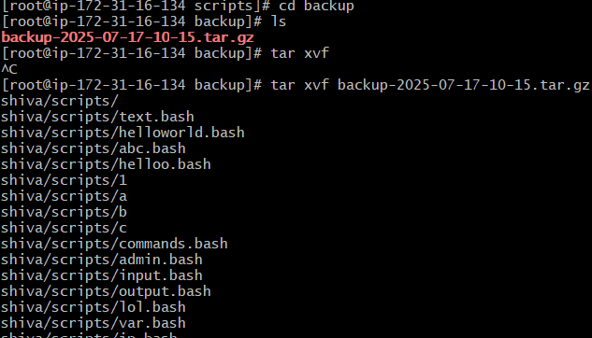

4) Create a bash script to install nginx in ec2 server.

5) Create a bash script to install ApacheTomcat in ec2 server.

6) Create a bash script to check list if nginx service is running or not,if not running then script should start the service.

7) Create a bash script for calculator.

8) Create a bash script to check if directory is avaialble or not,if not then create a directory.

9) Create bash script to delete last 3 lines for a file.

10) Bash script to monitor cpu and if it is more than 80% then send email notification.

11) Bash script to monitor disk space and if it is more than 80% then send email notification.

12) Bash script to monitor memory and if it is more than 80% then send email notification.

